**KABARAK UNIVERSITY**



**SCHOOL OF SCIENCE ENGINEERING AND TECHNOLOGY**

**IT PROJECT 1**

**INTE 414**

**IOT BASED GREENHOUSE MONITORING AND CONTROL SYSTEM**

**PRESENTED BY:**

**BARIMEN KIPRONO ROTICH–** **INTE/MG/2365/09/19**

**A PROJECT SUBMITTED TO THE DEPARTMENT OF COMPUTER SCIENCE AND INFORMATION TECHNOLOGY (UNDER THE SCHOOL OF SCIENCE, ENGINEERING AND TECHNOLOGY) IN PARTIAL FULFILMENT OF DEGREE IN INFORMATION TECHNOLOGY.**

**JUNE, 2022**

# Acknowledgment

I would like to acknowledge God Almighty for the strength, sound mind, and provision during the period of study. I wish to acknowledge the people whose contributions, guidance, encouragement and support – both financial and spiritual, which enabled me and facilitated my project proposal that has ultimately made me reach this level.

First, I wish to express my sincere gratitude to my supervisor, Mr.RUORO, for his enthusiasm, patience, insightful comments, helpful information, practical advice and unceasing ideas that have helped me tremendously at all times in my project proposal and writing of this thesis.  His immense knowledge, profound experience and professional expertise in Internet of things (IOT) has enabled me to complete this project proposal successfully. Without his support and guidance, this project would not have been possible. I could not have imagined having a better supervisor in my study. Surely your great counsel, skill, and experience could not have passed unnoticed.

I also wish to express my sincere thanks to Kabarak University for accepting me into the graduate programm and for their consistent support and assistance.

At last, I would like to extend my heartfelt thanks to my parents because without their help this project would not have been successful. Finally, I would like to thank my dear friends who have been with me all the time.

# Declaration and Approval

I Barimen

Kiprono Rotich Registration Number INTE/MG/2365/09/19 do hereby declare that this Project proposal is my original work and that it has not been presented for award of any degree in any university that I am aware of.

NAME: BARIMEN KIPRONO ROTICH

SIGN …………………………

DATE………………………...

**SUPERVISOR**

This paper has been submitted with my approval.

NAME: MR RUORO

SIGN …………………………

DATE…………………………

# 

# Dedication

I dedicate this project to my family precisely to my parents for the seemingly little yet huge impact they have made in my life in shaping me and making me believe in my strength rather than weaknesses and daring me to dream all through my course.

I would like to appreciate all my lecturers who instilled in me lifelong values and the desire for education. I hope this project work will be an inspiration to them too and those around them.

Finally, I would like to appreciate all of you who have contributed to my success and have not been mentioned above, remember that all your efforts are highly appreciated and you will never be forgotten for your stake in my life, God bless you all.

# Abstract

The aim of this project is to design a greenhouse monitoring system based on the Internet of things (IOT). A greenhouse is a covered area where plants grow and cultivate. It is also known as land of controlled crops and plants. There are some important parameters to be monitored inside the greenhouse are temperature, relative humidity and carbon-di-oxide.

Pervasive computing technology is invading our greenhouses. They are representing the technology solution to automate and improve the management of greenhouse.

Internet of things (IOT) was developed for connecting a billion of devices into an internet. A huge amount of information is transferred between the electronic devices. It is a new way to interact between device and people. This shows that how the embedded wireless system has been for future vision in the monitoring system.

Internet of things (IOT) will play a major role in day-to-day life in the future

A greenhouse is a steel-frame structure, covered by the anti-UV plastic sheet to protect the crops and environmentally controlled to maximize the crop's condition and productivity. Exposure to the extreme temperature during the hot season will affect the growth of the crops that influence the quality, yield, and profit per season. The Arduino software with Cisco Packet Tracer simulation is used to simulate the coding and the system. The environment of the greenhouse can be monitored, the temperature and humidity inside the greenhouse, the level of soil moisture and the level of water in the hydroponic tank. The system automatically executes the cooling, watering, lighting and warning notification features.

Table of Contents

Acknowledgment ii

Declaration and Approval iii

Dedication iv

Abstract v

CHAPTER ONE 1

**1.0 Introduction** 1

**1.1 Background to the study** 1

**1.2 Motivation** 2

**1.3 Literature survey** 2

**1.4 Current System** 3

**1.5 Statement of the Problem** 3

**1.5 Objectives** 4

**1.5.1 General objective** 4

**1.5.2 Specific objectives** 4

**1.6 Feasibility study of the proposed system** 4

CHAPTER TWO 5

LITERATURE REVIEW 5

**2.0 Introduction** 5

**2.1 Greenhouse Technology** 5

**2.1.0 Technologies for Greenhouse Automation Processes** 5

**2.2 Existing Greenhouse Electronic Management Systems** 6

CHAPTER THREE 11

RESEARCH METHODOLOGY 11

**3.0 Introduction** 11

**3.1 Research design Method** 11

**3.2 Methods of data Collection** 11

**3.2.1 Sampling** 11

**3.2.2 Survey and Census Information** 12

**3.3.3Literature sources** 12

3.3 System Design 13

**3.3.1 Hardware Design** 14

**3.3.2 Software Design** 14

**3.4 GREENHOUSE ENVIRONMENTAL CONTROL SYSTEMS AND TECHNOLOGY** 15

**3.4.1 Scenario I: Measuring temperature** 15

**3.4.3 Scenario II: Measuring Humidity** 16

17

**3.4.5 Scenario III: Measuring Light Intensity** 17

**3.4.7 Scenario IV: Measuring Water Depth** 18

**3.4.9 Scenario V: Gas Sensing** 19

**3.5 Scenario VI: IOT network for user notification** 21

**3.5.1 Greenhouse system overview design** 22

**3.5.2 System Architecture** 23

**3.6 Research ethics** 24

**3.7 References** 25

**3.8 APPENDIX: Activity schedule** 27

# CHAPTER ONE

## **1.0 Introduction**

A greenhouse is a Modern cultivating method that gives high yields during any season. This project shows the experimental, wireless embedded intelligent monitoring system for greenhouse which will improve crop growth and reduces cost and manpower. If monitoring is implemented using the wired networks, the cables connected to the devices need to be rearranged for every crop, so it wastes a lot of money and manpower. Therefore, it needs to be replaced by the internet of things (IOT) because it provides a new method for accessing the farmland information

## **1.1 Background to the study**

In Kenya, over 10 million people are food insecure, with the majority of them relying on food relief (Wanjiru *et al.,*2014). This is because Kenya is a rain fed country and over 80% of her landmass falls under arid and semi-arid climate which is characterized by droughts almost throughout the year (Hugo and Krosney, 2010). On occasions where there is rain, floods occur. This makes Kenya prone to climate vagaries. These climate uncertainties have led to severe food shortage and starvation. One possible solution to achieving food security is to use greenhouses, which enable the farmer to control the growth conditions thereby ensuring maximum crop yield throughout the year.

Greenhouses could be automated by utilizing microcontroller-based systems. These systems would monitor and control greenhouse parameters such as pH of soil, soil moisture, light intensity, relative humidity and temperature. The microcontroller would keep them at optimum levels on a continuous 24-hour basis.

In automated greenhouses, it is possible to manipulate crop production for certain economic advantages. For instance, a farmer may lower temperature to delay flowering. This is so that the flowers are ready for picking on a particular day; say on a Monday rather than having them picked over a weekend where he might pay more to the workers. He may also plan to harvest the flowers on days where there are cheaper flights (Pasian and Rausch, 2005).

Technology has redefined communication in many advantageous ways. Mobile technology has led to the coining of the term “global village” which can be seen through the fact that almost every adult nowadays owns a mobile phone and the decreasing cost of such devices over the years. An individual can be contacted at any time by the use of a mobile phone. Nowadays, cell phones are being used for more than making calls and sending messages; with the technological advancement, cell phone use has changed and various functions such as camera, radio or remote to control electrical appliances are standard. Exploiting cell phone’s capabilities can lead to new and profitable masterpieces.

Short Message service (SMS) is a very popular means of communication. The only disadvantage is that delivery of messages in real time depends on the phone’s network reception. This concept of instant messaging is what was used, in this research work, to prototype a system that acts as a platform for receiving or sending messages. The messages are commands sent to a microcontroller to control various greenhouse parameters or messages sent by microcontroller showing status of greenhouse parameters. This minimizes the needed work force and maximizes the output per greenhouse. With the use of this prototype, it is not necessary for the user to be always at the greenhouse to do management practices. In this study, a prototype system based on ATmega328 microcontroller that automatically monitors and controls temperature, relative humidity and light luminance in a greenhouse using sensors, SMS technology and Bluetooth signals was designed and implemented.

## **1.2 Motivation**

The recent scenario of climate change and its effect on the environment has motivated the farmers to install greenhouses in their fields. But maintaining a greenhouse and its plantation is very labour intensive. Majority of the farmers perform vital operations intuitively. Also, agricultural researchers are facing shortage of good quality of data which is crucial for crop development. Thus, we have developed such a cost-effective system using Internet of Things (IoT) technology which is focused on solving these particular problems. Our system automates the greenhouse maintenance operations and monitors the growth conditions inside the greenhouse.

## **1.3 Literature survey**

Information is the key to making sound decisions. Some farmers are unaware of the availability of a suitable machine, tool, or implement that could aid in their usually tedious work. They might be secluded from the technology by natural barriers and socio-political boundaries. Some farmers are even lackadaisical and seemingly uninterested in mechanization.

According to Weider hold (2007), Industry is rarely ready to accept an innovation when it first presented. There are many reasons for lack of acceptance: the two major ones he cites are:

The innovation is not understood by industry because, as a by- product of the innovation new terms have been defined.

The innovation is understood or at least understandable, but there are no resources at that time to try to develop and market the innovation,

Searles (2007) states that a subsistence farmer, which is the main target market for the greenhouses, cannot produce crops on a large scale if he does not know how to do so. It is hard to prevent problems such as soil erosion and degradation without knowing what to do to stop it.

She also stresses that there has been little effort towards education of the family farmers. In the cities there are resources available in order to educate a farmer but it is not accessible to many rural citizens. There has been no centralized effort to educate the majority of farmers on sustainable development issues.

Experience indicates that farmers are generally reluctant to changes in their farming activities for this is their way of life. They have the “wait- and-see” attitude. Like any new technology, greenhouse technology faces some of the same market problems as other innovations where few people would be willing to try out a new product. Most people would be unwilling to try out new innovative products such as greenhouse farming because they are uncertain of its success.

## **1.4 Current System**

The current greenhouses used in Kenya require a lot of human intervention for them to run. This takes up a lot of time and needs a very keen person to try and physically moderate the irrigation and aeration processes. Designing a self-operating greenhouse, in which monitoring and control processes are automated, saves time and lowers the operation costs. Our designed GSM and Bluetooth based remote wireless automatic monitoring system provides mobility during the monitoring and control process.

## **1.5 Statement of the Problem**

Different crops need different conditions to ensure maximum yield. Left to the varying and unpredictable natural conditions the production is very poor. The solution to this is the use of greenhouse. The greenhouse offers controlled environment that can be optimized for individual plants by controlling the main greenhouse parameters such as relative humidity, heat flow and light luminance. Some major concerns about greenhouse management methods have been cost and efficiency. The traditional greenhouses had simple control systems such as opening windows and turning on/off irrigation valves requiring the presence of people to operate it. A wired network has also been used which has proven to be more expensive in terms of installation as greenhouse sizes and number have increased over time. In this study, the aforementioned issues were addressed by developing a microcontroller-based system that automates the greenhouse monitoring and controlling processes using sensors. This will maximize the crop yields, minimize maintenance cost and save time.

## **1.5 Objectives**

### **1.5.1 General objective**

The general objective of this research work was to design, fabricate and implement a microcontroller-based prototype to monitor and control greenhouse parameters using sensors, SMS technology and Bluetooth signals.

### **1.5.2 Specific objectives**

1. To utilize different sensors to capture data for green house parameters,
2. Maintain Ideal Micro-Climate Conditions
3. Enhance Irrigation and Fertilization Practices
4. Sensors can monitor how much water and fertilizer your plants are getting/needing.

## **1.6 Feasibility study of the proposed system**

In future, apart from Android phones, the system can be connected to other communication devices like modems or satellite terminal for enabling remote data collection.

The system performance can be further expanded by increasing operating speed, memory capacity and instruction cycle period of microcontroller.

Moreover, Time bound administration of crop yielding materials like fertilizers, pesticides and insecticides can be introduced.

To operate multiple greenhouses concurrently, a multi-controller system can be developed

# CHAPTER TWO

# LITERATURE REVIEW

## **2.0 Introduction**

This chapter gives a general review on researches in the greenhouse systems that have been implemented in the attempt to automate greenhouse management processes. It outlines literature relevant to the project in areas of greenhouse technology, technologies for greenhouse automation processes and existing greenhouse control and monitoring systems.

## **2.1 Greenhouse Technology**

Technology is a body of techniques, methods, processes and designs used to achieve some intended purpose. It is the tool as well as the knowhow to use the tool (Dabadi, 2003). Greenhouse is a technology not only for enhancement of food security but also for overall economic growth of any nation. It is light weighted, translucent or transparent, enclosed structure in which plants are cultivated and is spacious enough to enable people do routine activities inside it environment (Narasaiah, 2007).

As opposed to open land, a greenhouse has many advantages some of which are: offers longer growing season since greenhouse retains heat hence growing of crops can extend even in cold seasons, one can farm even in bad weathers since crops are covered, a wide variety of crops can be grown even exotic plants that are not grown locally, plants are protected from predators and pest since crops are enclosed, one can grow crops without dangerous pesticide and greenhouse can be customized to ones needs, keeps inside insects like ladybugs that are beneficial to crop, and ensures growing of food all year round which allows one to enjoy lower food bills advantages.

Greenhouse technology should be embraced as a way of minimizing food insecurity in the country as it plays a key role in shifting from rain-fed farming to greenhouse for growing crops like vegetables and flowers under controlled environmental conditions. These environmental conditions are not easy to control by manual methods inside a greenhouse and hence there is need for an automatic system.

### **2.1.0 Technologies for Greenhouse Automation Processes**

Greenhouse control systems have become more automated in recent times (Soto- Zarazua *et al*., 2011). The means of automating the greenhouse can be broadly classified into wired and wireless technologies. There are several existing Wireless Technologies which are in use today. According to a survey conducted on the use of these platforms it was found that the most utilized wireless technologies are Wi-Fi, Bluetooth and ZigBee (Paavola, 2007).

**Bluetooth**

It is a wireless data transmission technique between fixed and mobile devices over short distances by means of short wavelength UHF radio waves in the ISM band (2.400 -

2.485 GHz) - this builds personal area networks (PANs). It was developed to replace RS-232 data cables. It transmits data in terms of packets with master/slave architecture by frequency-hopping spread spectrum radio technique. A master bluetooth accessory can link up to a maximum of seven accessories in a temporary computer networking via bluetooth technique. The accessories can change their positions such that the slave can act as master and vice versa. The only weakness of Bluetooth is that it has a short range for wireless communication. This might limit the area of coverage.

**Wi-Fi**

It is a technique dependent on IEEE 802.11 levels that is used for WLAN of devices. Wi-Fi uses ISM radio bands (2.4 GHz UHF and 5 GHz SHF) and can be utilized by electronic devices like desktops, smartphones, smart TVs, printers, digital cameras etc. Compatible electronic gadgets can link to one another over Wi-Fi via wireless access points or connected Ethernet devices. Access point has a range of about 25 m and the range can be more outdoor. Wi-Fi is potentially more vulnerable to attack than wired network since anyone within the range of network with access network interface can access. The cost of setting up a Wi-Fi network is much higher due to its area of coverage. This may also result in wastage of resources as per the small-scale farmers’ requirements

## **2.2 Existing Greenhouse Electronic Management Systems**

The existing greenhouse electronic management systems varies in terms of sensing technology, monitoring technology and software design as discussed in the following works;

Morais *et al.* (1996) designed and accomplished a climatic information collection network for greenhouse based on PIC6C71 and 87C592 microcontrollers. The system used data acquisition stations which were connected to solar panels and linked to a central station by a radio frequency link. The solar panels powered a 6 V, 600 mAh NiCd batteries for backup at night period. The system used LM35DS temperature sensor, MiniCap2 air relative humidity sensors, TSL230 light sensors and soil waters sensors. The base station main function was to control the data acquisition stations and store data collected by them. The data acquisition stations communicated with central station using RF links based on SIRLX-418F receiver and TXM-418F transmitter from a radio station. The data received by central station (based on 87C592 microcontroller) was sent to a PC through an RF link or CAN bus. Since communication was done through by RF, the system was cheap, flexible and could be operated wirelessly. There was no interference with normal operations in the greenhouse since no cables were used in the network. Solar panels have a problem of power in case there is heavy cloud cover this is challenge for this design.

Serodio *et al.* (1998) designed and implemented an integrated network, for greenhouse management, that linked several communication techniques. The central personal computer provided user interface, gave updates on control measures and availed report on sensors and actuators. The network that interconnected all the sensors was based on radio frequency technique. Each acquisition station worked as remote data collector and used 80C592 microcontroller. The network that interconnected all the actuators was based on radio frequency technique forming controller area network. The RF drivers used was a 10 mW transceiver (BIM-433-F at 433.092 MHz) for data communication to a radius of 400 m. CAN and RS-232 through cables provided an alternative to the RF links because transceivers were affected by lightning during rainy weather due to power surge. This system set up was expensive to set up.

Marhaento and Singh (2002) developed a programmable environment controller for the greenhouse environment using personal computers (PCs). The input part comprised of sensors for measuring water, temperature and humidity levels. The output comprised of actuators namely dripper for supplying water, two fans one for inflow and the other for out flow of air to enable ventilation of the system. Signal processing was facilitated by multiplexers, amplifiers, ADC and interface card. Greenhouse environmental controller (GEC) program was compiled under disc operating system. The program was such that the working of control could be manual or automatic and parameters could be adjusted to any desired levels. Humidity range was set as 80% to 95% while temperature range as 30oC to 33oC otherwise relevant actuators were activated automatically. The set ranges of parameters exceeded the set lower limits due to delay of the response time of the controller and the sensors. For this reason the lower limits were set a little bit higher and lower limits a little bit lower

Mizunuma *et al*. (2003) designed and implemented a rice seedling greenhouse structure based on a wireless local area network. The environmental data hub comprised of two weather sensors, four Soil sensors, three pyrheliometer, two net pyrradiometer and a Camera linked by WLAN to a data logger. The actuators were pump for water supply and motor for opening and closing windows. The main wireless LAN operated at 2.4 GHz, with signal rate of 2 Mbit/s and transmission range of a radius of 5 Km.

Obanda (2010) designed and fabricated a greenhouse electronic system Based on the Z80 microprocessor. The hardware consisted of a Z80 CPU, two 8255 PIA‟s, a 2716 EEPROM, a 6116 RAM, an HIH-4000 humidity sensor, an LM-35 temperature sensor and two ADC 0804 analogue to digital converters, a clock and reset circuitry and 7- segment displays and LEDs. The software was coded in the Z80 assembly language. This system monitored temperature, humidity and light illuminance on a continuous basis. It measured and displayed these parameters and activated appropriate devices whenever these variables fall outside predetermined ranges. Relative humidity was controlled by a water sprinkler, temperature by a fan and heater and light illuminance by a lighting system. The system had one major problem; it had no remote monitoring station.

Quan (2011) designed and tested a C805F020 microcontroller based automatic greenhouse prototype. The sensing unit comprised of sensors such as SHT75 for measuring humidity and temperature, NORP12, TGS4161 for measuring CO2 THERM200 for mastering soil temperature and VG400 for measuring soil moisture. The central unit comprised of a personal computer, USB cable and 19200 baud 2.4 GHzXStream RF modem. The central unit collected data, processed data, controlled greenhouse climate and displayed information to the user. The coordinator unit comprised of C805F020 microcontroller, Xbee module, 19200 baud 2.4 GHz XStream RF modem, relay interface point and power supply provided by LM2594M power regulator. The actuator unit comprised of bulbs, CO2 injector, exhaust fan, sprinkler, heater and a thermal shade.

Rana *et al.,* (2013) designed and implemented a wireless greenhouse management system. The system architecture comprised of a control station and three sensor stations. The sensor stations (nodes) comprised of XBee modules and three sensors. Each node measured temperature, light and humidity, and periodically sent the data to the central computer. The XBee modules supported ZigBee S2 links which were set to read sensors analogue values and send them as packets of data. The central control station comprised of XBee module linked to a computer via universal serial bus (USB). The sensor nodes measured the green house parameters, converted the values to digital form, and then relayed them wirelessly to the central control station.

Guraiah and Naga Swetha (2014) developed a GSM-based greenhouse system for agricultural field. The controlling unit comprised of ARM7LPC2148 microcontroller. The input comprised various wireless sensors to measure light intensity, humidity and temperature levels. The output unit comprised of LCD, personal computer, GSM and actuators. The measured values were displayed on the LCD and as well as GPRS webpage on a central personal computer. The program for the system was developed in C language using Keil software. The system lacked mobile monitoring system.

Swarna *et al.,* (2015) fabricated a greenhouse monitoring system using on the Arduino uno board and computer. The hardware comprised of data acquisition card, Arduino board, personal computer and sensors. In the greenhouse multiple sensors were used to measure the parameters. They used DHT11 sensor, soil hygrometer sensor, CO2 sensor and light sensor. Graphical user interface (GUI) was used via LabVIEW. The sensor measured values were transmitted to the personal computer where by, through LabVIEW simulations, monitoring of greenhouse parameters was possible. This design lacked actuation unit.

Saibaba and Naidu (2016) designed an intelligent greenhouse system based on LPC2148 controller. It had two nodes each node had LPC2148 microcontroller, MCP2515 controller and MCP2551transrecever. The first node comprised of sensors for soil moisture, temperature and humidity. The second node interfaced LCD and buzzer. The project was implemented using advanced CAN protocol and a microcontroller. Different parameters were monitored in these nodes and updated. Node 1 collected sensors values and sent them to the second node via CAN bus. The second node-controlled alarm system according to the received data. The CAN protocol was implemented using SPI lines of ARM7.

Pushkar and Armey (2016) designed an embedded system for greenhouse management. The hardware comprised of the controller PIC18F452, sensors, Graphical LCD, EEPROM, Real time clock (RTC), and relays. Five sensors were used namely; LM35D for temperature measurement, NORP-12-RS for measurement of light, FC-28-D for measurement of soil moisture, and SY-HS-220 for measurement of humidity. RTC provided date and time to the controller while EEPROM stored the monitored information. For control action purpose the relays were utilized to ON and OFF the actuators. Graphical LCD displayed real time parameters and the graphs for analysis. Controllers’ UART transmitted data from EEPROM to a personal computer for viewing via UART USB module. The actuators were cooling fan and heater to regulate

temperature, light-bulb to increase light, and small heater to raise humidity. This system could not be monitored or controlled from a distance.

Ramya *et al.,* (2016) developed and implemented a prototype to monitor and control greenhouse climate using wireless sensors network (WSN) and internet of things (IOT). It consisted of the sensing unit, controlling part, monitoring part and message sending and receiving part. In the sensing part, the sensors included were LM35 temperature sensor, MQ-5 toxic gas sensor and fire sensor. The sensors detected various parameters and displayed them on the LCD. The sensors were connected to P89V51RD2 microcontroller which was the controlling part. The analogue sensors were connected through ADC. The microcontroller was then connected to a pump, buzzer and a GSM module through MAX 232. When the moisture was less than the preset values microcontroller would turn on the pump to sprinkle water. If fire was detected, then the buzzer would be turned on to notify the user. A message sending part was a GSM module which sent the values of greenhouse parameters to a predefined number. The receiver was a smart phone with an android application that played a predefined audio sound.

From the research works discussed in this section, it is clear that most existing greenhouse systems lack mobility during the monitoring process. Our designed GSM and Bluetooth based remote wireless automatic monitoring system provides mobility during the monitoring process. The control and monitoring are instant and the system is programmable by the use

# CHAPTER THREE

# RESEARCH METHODOLOGY

## **3.0 Introduction**

This chapter focuses on hardware, schematic and software designs of the automatic greenhouse prototype. First, the chapter discusses in details the LDR sensor, the DHT11 sensor, the ATmega328 microcontroller, the LCD, the HC05 Bluetooth, the GSM SIM800L and the 5 V 4 channel relays. Secondly, the chapter discusses in details the prototype schematic design to demonstrate how each component was interfaced to the microcontroller to up come with the expected prototype design. Lastly, the chapter gives an overview on Arduino programming kit in the effort to design the system software

## **3.1 Research design Method**

Waterfall model will be employed in this study. This is because of its linear sequential development of phases, where each phase depends on the deliverables of the previous phase as shown by the steady downward flow of the phases. This method is appropriate because the progress is seen as following steadily downwards from the requirement analysis all through to the phases to implementation and maintenance. The model involves six processes that are all linked to one another.

## **3.2 Methods of data Collection**

The data collection process in any survey operation has a high impact on data quality. Along with the questionnaire and sample design, the data collection and capture processes can be major sources of measurement error—defined as the difference between the value of the variable provided by the respondent and the true, but unknown, value of that variable. In obtaining the data for greenhouse monitoring and control system, I used the following methods for data collection.

### **3.2.1 Sampling**

Sampling is a method that allows researchers to infer information about a population based on results from a subset of the population, without having to investigate every individual

The goal of sampling for a soil test is to efficiently take a sample which best represents the nutrient status of the crop or the problem to be diagnosed.

The first step I did is to identify the crop unit(s) to be sampled - bench, greenhouse, etc. In a mixed greenhouse, crops of different species must be sampled separately for the tests to have any value. If a problem is being diagnosed it is best to have a sample from both normal and abnormal plants for comparison.

In my sampling technique, I did consider the following questions before a species of a crop is grown in the greenhouse

1. What is the crop?
2. What is the age or stage of development?
3. What is the growth medium (soil or soilless, commercial brand)?
4. What is the fertilizer program (i.e., specific fertilizer, rate [ppm], frequency of application)?
5. Is there a problem and if so what is it?

### **3.2.2 Survey and Census Information**

Provide the best agricultural, production and energy statistics for GHG inventories

Generally, these data are compiled by national statistical agencies or relevant ministries for national policy purposes or to comply with international demand for data

**Survey data**:

Derived from sampling and do not include real data for the whole population

**Census data**:

Based on a complete count of the whole population

Limited in detail and can be costly and time consuming

Information on specialized data sources

I use data from bodies such as National Statistical Agencies, national regulatory authorities

Also, from National and international statistics and other sources of specialized literature such as UN statistics, US Geological Survey, etc.

### **3.3.3Literature sources**

I obtain more data from books written by different experts about crop production. The Greenhouse Expert book, by Dr. D. G. Hess Ayon. It is a book with lots of information about owning and growing inside your greenhouse. It also advises on what type and size of greenhouse might be right for you. It talks about the British culture of greenhouse use and is gives detailed lists of numerous plants and the necessitates to care for them

# 3.3 System Design

To come up with a system that puts ideas on paper and gather the necessary requirements from the users. I used the following models: -

1. Block diagram.
2. Data flow diagram
3. Use Case Diagram
4. **Block diagram**



LCD

DHT11

Sensor

GSM

module

**Microcontroller**

LDR

sensor

Bluetooth Module

Relay Module Interface

Relay for Fan

Relay for Bulb

Relay for Sprinkler

Relay for Heater

**Figure.3.3.0 The Prototype Greenhouse Block Diagram**

## **3.3.1 Hardware Design**

Figure 3.1 shows a flow diagram of the designed greenhouse prototype. The designed prototype has the following units: sensing, processing and storing, displaying and indicating, wireless communication, power supply, and actuation. The system comprises of microcontroller chip, LCD, GSM, Bluetooth, sensors, relays and actuators. The microcontroller was interfaced with two sensors to measure different greenhouse parameters such as heat levels, light luminance, and relative humidity. The analog data obtained from the light sensor was digitized via onboard ADC. The digital data was fed to the microcontroller which made decisions and activated the relevant actuators according to the installed program. The LCD displayed sensor readings and the status of the actuators. The data provided by the sensors was recorded in EEPROM which sent it to the microcontroller for analysis on request. The microcontroller communicated with the GSM module by AT Commands, which were used to send and receive short messages.

**Hardware requirements**

1. Temperature Sensor TMP 36
2. H-bridge motor driver
3. DC Motors
4. Photoresistor
5. LCD display
6. Ultrasonic sensor HC-SRO4
7. Buzzer
8. Gas sensor
9. Servo motor
10. Arduino

## **3.3.2 Software Design**

In microcontrollers and computers, programming refers to writing a sequence of directives, executable by the processor in a given order to carry out preset task. It involves debugging, and troubleshooting instructions and instruction sequences to ensure collect task implementation. There are certain words, grammar and rules for programming languages.

There are three types of programming languages for microcontrollers depending on closeness of statements in the language resemblance of the operations done by the controller. The three levels of programming languages are: machine code, assembly language and high-level language.

In machine code instructions are written in binary form (digits 0 and 1), stored as ‘LOW’ and ‘HIGH’ voltages. It is the lowest level of programming language and microcontrollers understand this language. The assembly language is the English representation of the machine code – it is based on mnemonics and hexadecimals codes. Architecture knowledge of the microcontroller is crucial in this language. The high-level language uses words and statements easily understood by human. Examples of high-level languages are BASIC, Pascal, C++ and Java. A program called compiler enables conversion of the programs in high level language to binary form (digits 0 and 1) which can be uploaded to computer memory for execution. High level languages are easy to work with, however, assembly languages have the following merits;

* Their programs are faster to execute and require less memory space.
* Enable direct exploitation of the features of microcontroller
* Enhance direct and accurate control of microcontroller resources such as RAM, Ports etc.
* They have less rules and restrictions.

**Software Requirements**

**Data Collection Module:** This module collects and decodes the digital signals input from the sensor nodes and extracts the usable data.

**Data Processing Module:** This module preprocesses the usable data for analytics to be done. Also, it uses this data for actuation purposes in timing and sensor-based modes.

**System Configuration Module:** This module is used to configure the system primarily for setting threshold values and preprocessing fine tuning.

**IoT Cloud:** Being an IoT system on site we cannot load resource intensive the analytics code in the server thus using IoT cloud we can perform analytics and store the data collected for future use easily and efficiently.

**End User Web Application:** This will the user interface of the system, this module will contain a control panel where the user can watch and control the system easily.

## **3.4 GREENHOUSE ENVIRONMENTAL CONTROL SYSTEMS AND TECHNOLOGY**

### **3.4.1 Scenario I: Measuring temperature**

The wireless greenhouse temperature monitoring system allows tracking the temperature levels in greenhouses. The system is monitoring environmental conditions for 24/7 and sending alerts in case the set temperature and humidity conditions fall out of optimal ranges.

There is an option to select individual min/max parameters of the temperature range for each wireless sensor as well as setup allowed time of violence out of recognized parameters. This feature helps to focus on severe cases, avoiding alerting many un-important events.

The optimal temperature range is from 20℃ ..25℃, Below 20℃ the MCU board sends analog signals to the temperature stabilizer heating element which starts to automatically warm up the environment keeping the plants healthy. Above 25℃ the MCU board sends analog signals to the temperature stabilizer cooling element which starts to decrease the temperature thus maintaining a sustainable environment.

**Flow diagram for Scenario I**

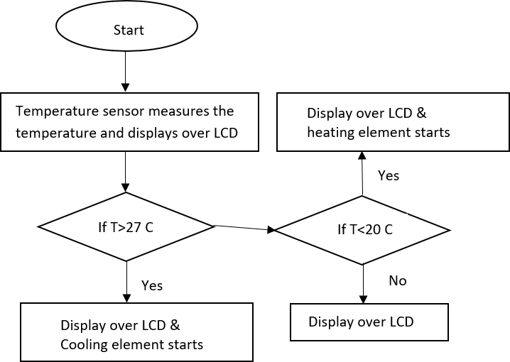

**Figure 3.4.2 Measuring Temperature**

### **3.4.3 Scenario II: Measuring Humidity**

The humidity sensor will sense the humidity of the value of the humidity. If the value is higher than the predefined value it will send a message to the owner that the humidity is high.

**Flow diagram for Scenario II**

### 

### 

### 

**Figure 3.4.4 Measuring Humidity**

### **3.4.5 Scenario III: Measuring Light Intensity**

The most common type of photoconductive device is the Photoresistor which changes its electrical resistance in response to changes in the light intensity.

If resistance is less than 100, then it is too bright and the owner will be notified of this change.

If resistance is greater than 180, then it is too dark and automatically artificial lighting (LED) will start and the owner will be notified of this change.

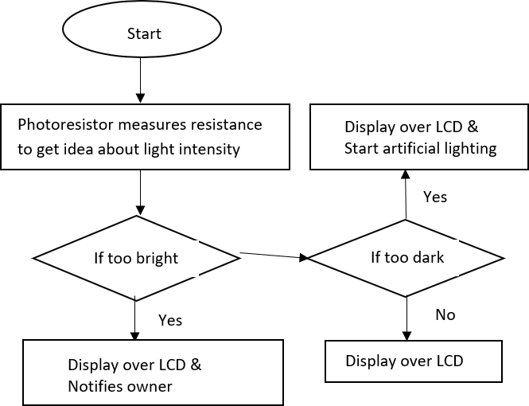**Flow diagram for Scenario III**

**Figure 3.4.6 Measuring Light Intensity**

### **3.4.7 Scenario IV: Measuring Water Depth**

Here we use an ultrasonic sensor to measure the depth of water in the water pump.

If the measured distance is greater than 200 cm, it represents low water level in the tank and pump will automatically start.

If measured distance is less, it means water level is high and pump does not start.

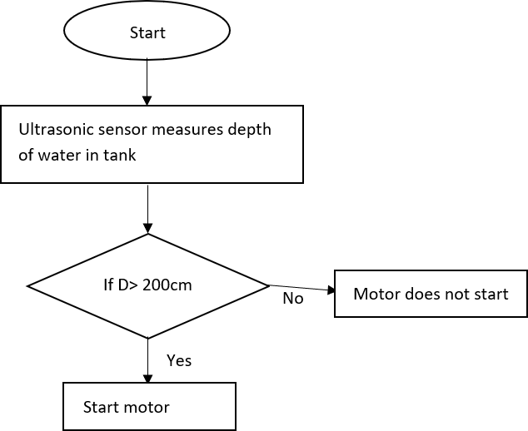**Flow diagram for Scenario IV**

**Figure 3.4.8 Measuring Water Depth**

### **3.4.9 Scenario V: Gas Sensing**

A gas sensor is a device which detects the presence or concentration

of gases in the atmosphere. Over here it detects when the atmosphere gets toxic due to harmful gases.

If smoke concentration is very high a buzzer is used to notify the owner.

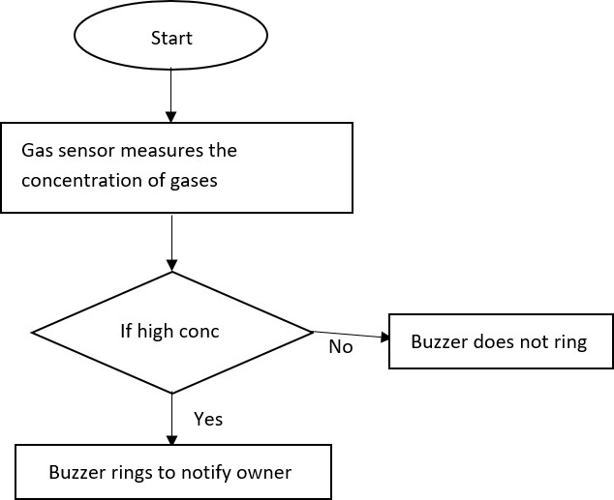**Flow diagram for Scenario V**

**Figure 3.4.9 Gas Sensing**

### **3.5 Scenario VI: IOT network for user notification**

The temperature and humidity values are continuously being displayed by the LCD monitors. It is displayed by the server and as well on the laptop.

Any person or device who is connected in this network can get this data from anywhere. Online reporting software supports multi user environment with individual notification schedule.

The wireless sensors have built-in battery that works up to 5 years.

The sensors read environment parameters and deliver them to the online reporting software every 5 minutes.

One data gateway supports up to 200 wireless humidity and temperature sensors within a radius of 150 m (or up to 500 m using signal repeaters), so you can monitor several greenhouses at the same time using one data gateway that reduces the cost of the system

**Flow diagram for Scenario VI**

Start

MCU Board sends analog signals to

humidity sensor

If H>70%

and H<80%

No

Yes

Display over LCD

Display over LCD &

Notify user

Humidity sensor measures the

humidity and displays over LCD

Figure 3.5 **IOT network for user notification**

## **3.5.1 Greenhouse system overview design**

The proposed greenhouse in this paper shows the UI of u-Greenhouse integrated management system applying the proposed middleware. The system UI displays information such as illuminance, temperature, humidity, CO2, etc. collected from the environmental and soil sensors

install in the greenhouse as a text form, enabling real-time image information of the greenhouse and also controlling the CCTV, and allowing notification of the working state of the greenhouse

environmental control facilities and their control. In addition, it was implemented so as to allow famers to directly set a range of context-aware and event services so that it could provide context-aware serviced such as automatic control of the greenhouse environment, etc. and the SMS

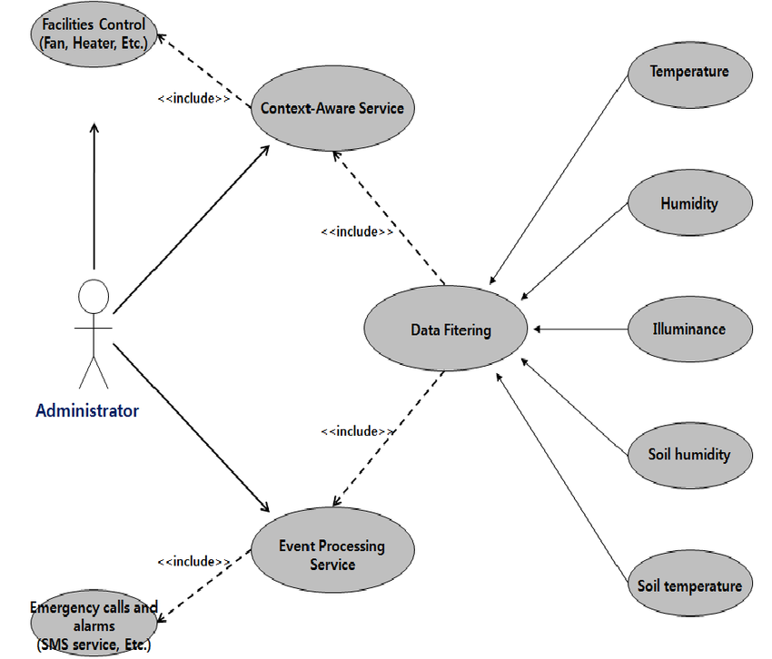notification service for dangerous situations. The use case diagram below show the greenhouse system overview design

Figure use-case diagram

## **3.5.2 System Architecture**

This project is implemented in green house to monitor soil moisture, humidity, temperature, presence of fire, color of leaves and detection of toxic gases. The sensors have huge amount of implementations. This project can be used for any type of irrigation fields, in nursery, botanical gardens. This project can be implemented in any closed area which located remote places which need to be monitored without human presence.

The humidity sensor will sense the humidity of the value of the humidity. If the value is higher than the predefined value it will send a message to the owner that the humidity is high.

The temperature sensor will sense the value of the temperature and if the temperature is high the sensor will display it in the LCD monitor and send a message to the owner through GSM.

**ARTIFICIAL LIGHTS**

**(IOT enabled sensors bulbs)**

**WATERPUMP**

**(Supply water to greenhouse)**

**ULTRASONIC SENSOR**

(Detect distance)

Communication is done via UART mode

**PHOTORESISTOR**

**(Light intensity)**

**ARDUINO**

**read inputs - light on a sensor, a finger on a button, or a message - and turn it into an output - activating a motor, turning on an LED**

**GAS SENSOR**

**(Detect types of gases)**

Signaling device

**BUZZER**

**(Gives out audio signal)**

(GSM module sends temperature information)

Coordinate using DHT11

**LCD DISPLAY**

**(Monochrome display)**

**COOLING ELEMENT**

**(Lowers temperature)**

**HEATING ELEMENT**

**(Increases temperature)**

**TEMPERATURE SENSOR**

**(Detection of temp changes**

Remotely detect IR energy emitted (send signal to calibrated circuit)

**Figure System Architecture**

## **3.6 Research ethics**

Here I dully observed ethical matters as the project fully is about a natural interaction of human being. They provide their accurate details this ensures honesty, transparency and fairness in their interactions and brings about togetherness and unity.

## **3.7 References**

* **Zhao, Ji-chun, et al. "The study and application of the IOT technology in agriculture." Computer Science and Information Technology (ICCSIT), 2010 3rd IEEE International Conference on. Vol. 2. IEEE, 2010.**

[**Google Scholar**](https://scholar.google.com/scholar?q=Zhao,%20Ji-chun,%20et%20al.%20The%20study%20and%20application%20of%20the%20IOT%20technology%20in%20agriculture.%20Computer%20Science%20and%20Information%20Technology%20,%202010%203rd%20IEEE%20International%20Conference%20on.%20Vol.%202.%20IEEE,%202010.)

* **Nelson, P.V.: Greenhouse Operation and Management. Prentice Hall, NJ (1995)**

[**Google Scholar**](https://scholar.google.com/scholar_lookup?&title=Greenhouse%20Operation%20and%20Management&publication_year=1995&author=Nelson%2CPV)

* **Nie, J., Sun, R., Li, X.: A precision agriculture architecture with cyber-physical systems design technology. Appl. Mech. Mater. 543–547, 1567–1570 (2014)**

[**CrossRef**](https://doi.org/10.4028%2Fwww.scientific.net%2FAMM.543-547.1567)[**Google Scholar**](https://scholar.google.com/scholar_lookup?&title=A%20precision%20agriculture%20architecture%20with%20cyber-physical%20systems%20design%20technology&journal=Appl.%20Mech.%20Mater.&volume=543%E2%80%93547&pages=1567-1570&publication_year=2014&author=Nie%2CJ&author=Sun%2CR&author=Li%2CX)

* **Mišiü, V., Mišiü, J.: Machine-to-Machine Communications Architectures, Technology, Standards, and Applications, pp. 1–30. CRC Press, Taylor & Francis Group, UK and USA (2014)**

[**Google Scholar**](https://scholar.google.com/scholar_lookup?&title=Machine-to-Machine%20Communications%20Architectures%2C%20Technology%2C%20Standards%2C%20and%20Applications&pages=1-30&publication_year=2014&author=Mi%C5%A1i%C3%BC%2CV&author=Mi%C5%A1i%C3%BC%2CJ)

* **Tung, S., Liu, Y., Wejinwa, U.: Special issue on control and automation in cyber-physical systems. Trans. Inst. Meas. Control 36(7), 867 (2014)**

[**CrossRef**](https://doi.org/10.1177%2F0142331214534142)[**Google Scholar**](https://scholar.google.com/scholar_lookup?&title=Special%20issue%20on%20control%20and%20automation%20in%20cyber-physical%20systems&journal=Trans.%20Inst.%20Meas.%20Control&volume=36&issue=7&publication_year=2014&author=Tung%2CS&author=Liu%2CY&author=Wejinwa%2CU)

* **Moreira, L., Leitão, S., Vale, Z., Galvão, J., Marques, P.: Analysis of power quality disturbances in industry in the centre region of Portugal. In: Camarinha-Matos, L.M., Barrento, N.S., Mendonça, R. (eds.) DoCEIS 2014. IFIP AICT, vol. 423, pp. 435–442. Springer, Heidelberg (2014)**

[**CrossRef**](https://doi.org/10.1007%2F978-3-642-54734-8_48)[**Google Scholar**](https://scholar.google.com/scholar_lookup?&title=Analysis%20of%20power%20quality%20disturbances%20in%20industry%20in%20the%20centre%20region%20of%20Portugal&pages=435-442&publication_year=2014&author=Moreira%2CL&author=Leit%C3%A3o%2CS&author=Vale%2CZ&author=Galv%C3%A3o%2CJ&author=Marques%2CP)

* **Galvão, J.R., Jesus, C.D., Ascenso, R.M.T.: Sustainable energy model in high rate hotel. In: International Conference on Energy for Sustainability (EfS) Proceedings, Coimbra (2015)**

[**Google Scholar**](https://scholar.google.com/scholar?&q=Galv%C3%A3o%2C%20J.R.%2C%20Jesus%2C%20C.D.%2C%20Ascenso%2C%20R.M.T.%3A%20Sustainable%20energy%20model%20in%20high%20rate%20hotel.%20In%3A%20International%20Conference%20on%20Energy%20for%20Sustainability%20%28EfS%29%20Proceedings%2C%20Coimbra%20%282015%29)

* **Kessler, J.R.: Chrysanthemum-commercial greenhouse production. Auburn University (2015).**[**http://www.ag.auburn.edu/hort/landscape/Potmum.htm**](http://www.ag.auburn.edu/hort/landscape/Potmum.htm)**. Accessed October 2015**
* **PVsyst: photovoltaic software, January 2015.**[**http://www.pvsyst.com/**](http://www.pvsyst.com/)

**Carbon Trust and Defra: Guide to PAS 2050 How to assess the carbon footprint of goods and services. BSI, London (2008)**

**G.J. Timmerman, P.G.H. Kamp**

* **"Computerised environmental control in greenhouses."**

**PTC, The Netherlands, Page (s), 15124 (2003)**

[**Google Scholar**](https://scholar.google.com/scholar?q=Computerised%20environmental%20control%20in%20greenhouses.)

* **Greenhouse guide. (Referred 20.04.2008). [Online]. Available:**[**http://www.littlegreenhouse.com/guide.shtml**](http://www.littlegreenhouse.com/guide.shtml)**.**

[**Google Scholar**](https://scholar.google.com/scholar?q=Greenhouse%20guide.%20.%20Online.%20Available:%20http:www.littlegreenhouse.comguide.shtml.)

* **Zhao, Ji-chun, et al. "The study and application of the IOT technology in agriculture." Computer Science and Information Technology (ICCSIT), 2010 3rd IEEE International Conference on. Vol. 2. IEEE, 2010.**
* [**Google Scholar**](https://scholar.google.com/scholar?q=Zhao,%20Ji-chun,%20et%20al.%20The%20study%20and%20application%20of%20the%20IOT%20technology%20in%20agriculture.%20Computer%20Science%20and%20Information%20Technology%20,%202010%203rd%20IEEE%20International%20Conference%20on.%20Vol.%202.%20IEEE,%202010.)
* **Dan, Liu, et al. "Intelligent Agriculture Greenhouse Environment Monitoring System Based on IOT Technology." Intelligent Transportation, Big Data and Smart City (ICITBS), 2015 International Conference on. IEEE, 2015.**
* [**Google Scholar**](https://scholar.google.com/scholar?q=Dan,%20Liu,%20et%20al.%20Intelligent%20Agriculture%20Greenhouse%20Environment%20Monitoring%20System%20Based%20on%20IOT%20Technology.%20Intelligent%20Transportation,%20Big%20Data%20and%20Smart%20City%20,%202015%20International%20Conference%20on.%20IEEE,%202015.)

## **3.8 APPENDIX: Activity schedule**

**I. Schedule**

|  |  |  |  |  |
| --- | --- | --- | --- | --- |
| **Month**  **Activity** | **may** | **June** | **July** |  |
| Introduction |  |  |  |  |
| Background study |  |  |  |  |
| Problem statement |  |  |  |  |
| Objective’s formulation |  |  |  |  |
| Feasibility of the study |  |  |  |  |
| System requirements |  |  |  |  |
| Schedule |  |  |  |  |
| Budget |  |  |  |  |

|  |  |  |  |
| --- | --- | --- | --- |
| Chapter 2 Literature review |  |  |  |
| Chapter 3 Research design |  |  |  |
| Data collection methods |  |  |  |
| Design diagrams Context diagram Level 1 DFD  Use case diagram |  |  |  |
| Research ethics |  |  |  |